**Steps to Set up Oracle Database :**

* Download Oracle version : Oracle 12.1.0.2 which is compatible with Claim Center 9.
* All the detailed Installation steps of Oracle Database are available in the below link

<https://www.oracle.com/webfolder/technetwork/tutorials/obe/db/12c/r1/Windows_DB_Install_OBE/Installing_Oracle_Db12c_Windows.html>

* Create the Database needed for Claim Center using Database Configuration Assistant which gets Installed as part of Oracle database above.
* There are many other components like Oracle JVM, Oracle Multimedia get Installed as part of Step number 3.

**Prerequisites for Claim Center and Contact Manager Installation:**

1. Java 1.8 (jdk-8u181-windows-x64.exe for Windows 64 bit)
2. Ant 1.8 or above(apache-ant-1.9.13-bin.zip for Windows 64 bit)

**Claim Center configuration with Oracle DB :**

* Connection string?
* Create a new database instance for ClaimCenter.

Guidewire recommends that you not share the ClaimCenter database with other data or applications.

* Create one or more tablespaces to support the ClaimCenter logical tablespaces. Guidewire recommends that you create a separate tablespace for each logical tablespace:

**Logical Name Usage**

CC_ADMIN Stores system parameters.

CC_OP Stores the main ClaimCenter data tables.

CC_TYPELIST Stores system code tables.

CC_INDEX Stores system indexes.

CC_STAGING Stores inbound staging data tables.

In SQL Developer Go to -> View menu -> Select DBA -> connect to the Claimcenter Database -> then create the above Table spaces by navigating to Storage folder in the Database.

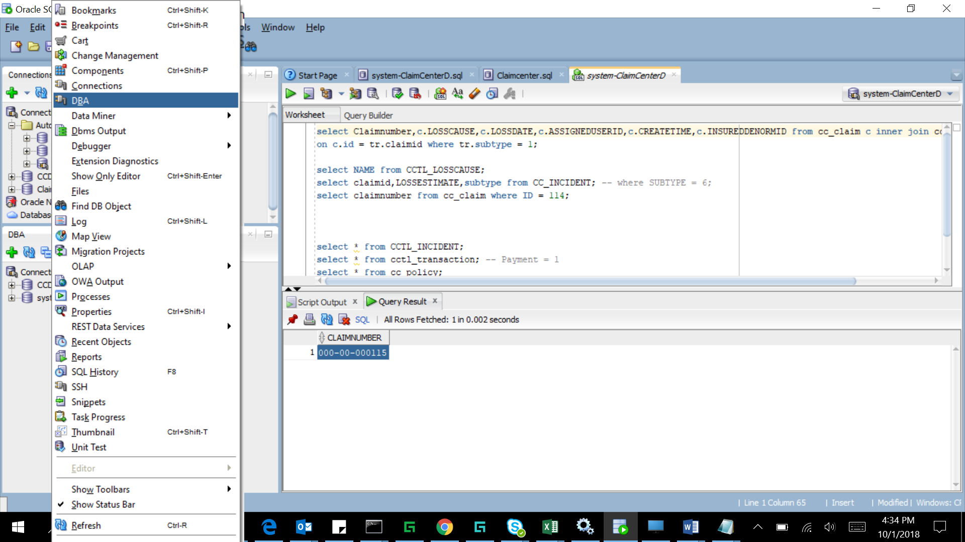

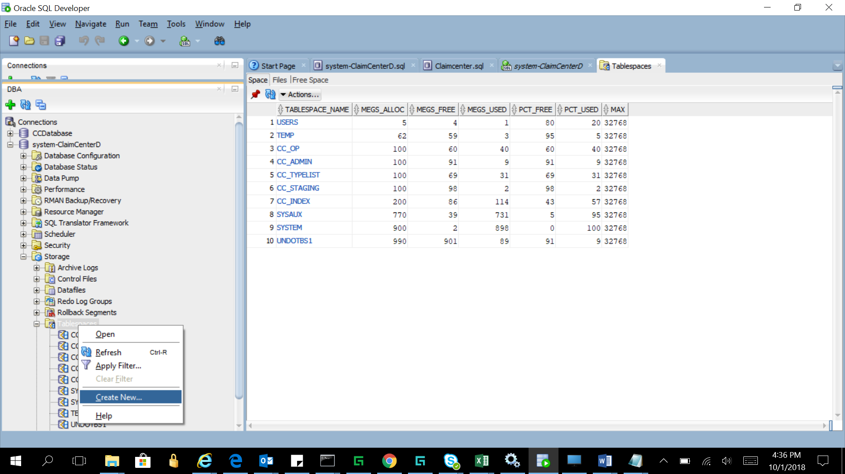

* Create a single database user, ccUser, in the ClaimCenter database.
* Grant ccUser the following permissions:

• alter session

• create procedure

• create sequence

• create session

• create table

• create trigger

• create view

• query rewrite

• select any dictionary

* Grant quota on all the tablespaces listed in step 2 to the ccUser.

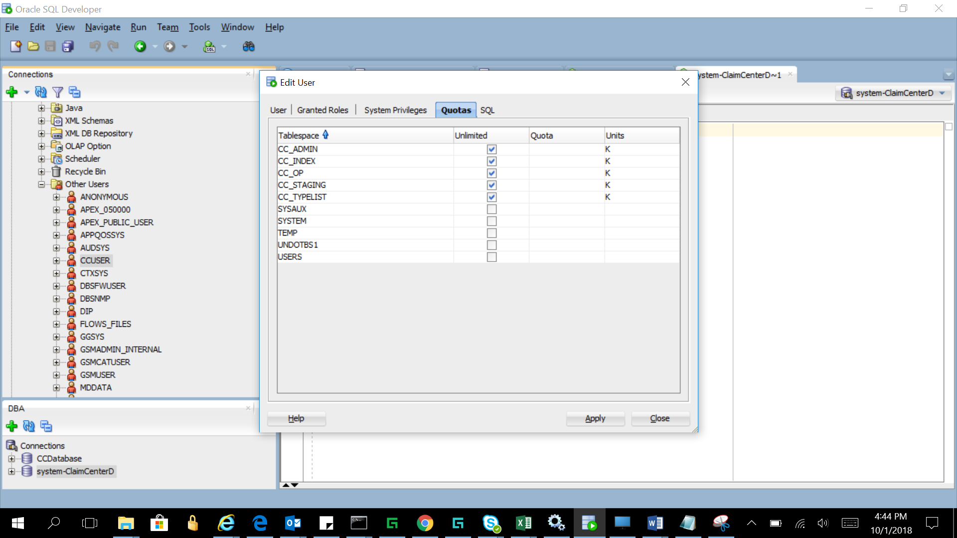

* Set default tablespace for ccUser to the one being mapped to the OP logical tablespace.

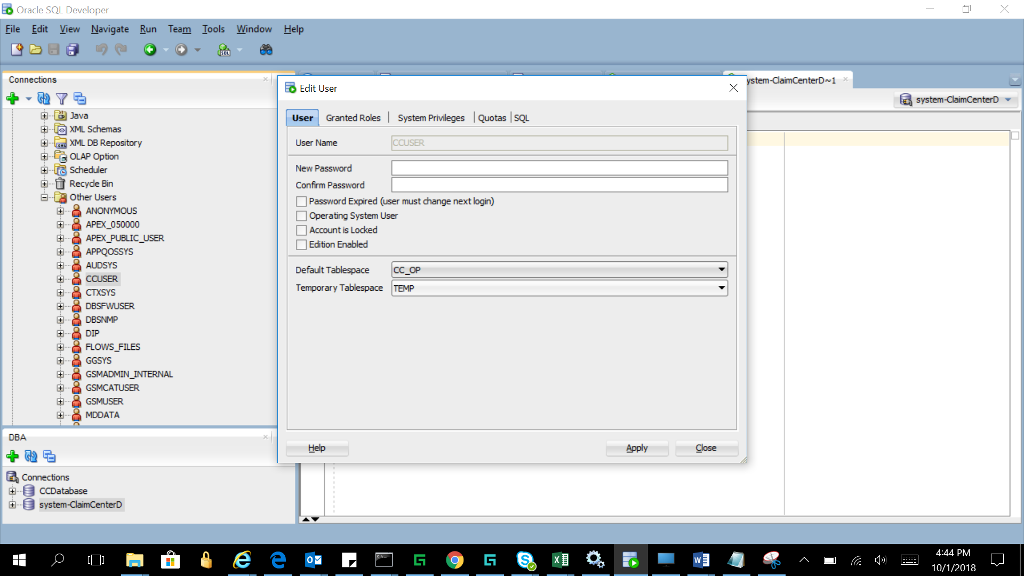

Open database-config.xml in the Claim center and update the details as below:

